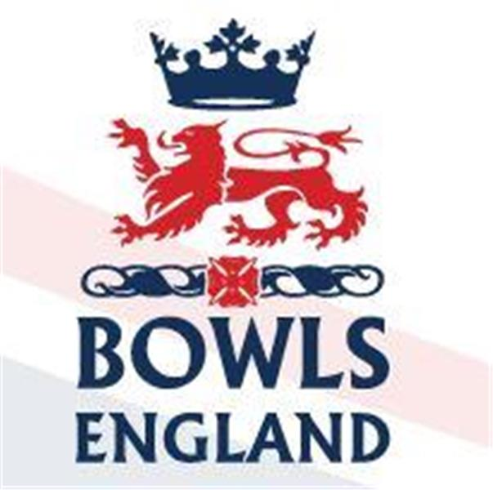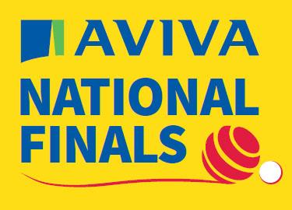
10th August to 27th August 2023 – Leamington Spa, Warwickshire.

Day 9 Review

Men’s Senior Pairs

Day 9 saw our “Senior” bowlers take centre stage. Seniors for Bowls England means over 55 and yes, I’m nearly with them

First up on B2 Attilio Ciampini (Uxbridge) and Dave Pitt (Cambridge Park) took on Simon Varty and Tony Hill of Bucks. A very tight game ensued with neither side gaining any solid degree of control. Attilio and Dave trailed throughout the game but eventually went down the last end level. With one bowl to come Bucks held the shot but Dave played the perfect draw to score the winner and take the game 19-18. That shot can now be seen on Bowls England’s social feed under a section call “the running bowl”

Elsewhere in the first round there was an upset as Legend of the Game Andy Thomson and his partner Martyn Sekjer from Kent lost 17-20 to Alan Ashby and Anthony o’Leary of Northamptonshire. Peter Ward and Chris Daniels of Hampshire lost 16-20 to Dave Smith and Ged Costello of Dorset whilst the new Men’s Champion of Champions Warwickshire’s Graham Ashby edged hrough 14-13 against Kenny Bolton and Lee Dickson from Sussex.

Round 2 and the Middlesex pair would play Gary Myerscough and Steve Pallas from Northumberland. On D5. They had got through their first rd tie 20-16 against Surrey. Gary has, like Attilio, also qualified in the Senior Singles.

Attlio and Dave made a good start to the game and led 5-1 after 4 ends. At the next check they were still up 7-5 with some good bowls being played by both sides. At the halfway stage the Northumberland lads had squared the game at 7 all. A Single apiece was followed by a pair and another single to the N’land lads. 8-11 with 5 to play. Middlesex score 2 on the 14th end but on the 15th the N’land skip plays controlled weight to turn his own bowls in – twice and draws a 3rd. Damaging blow. 10-14. Middx fight back and secure a double and a single to go down the last end one behind. Tilli draws shot but the N’land lead knocks the jack out to the side. The skip draws 2 more in and Dave has his last bowl to save the game. Sadly he’s high and heavy and his wood sails by. Northumberland win 17-13.

Elsewhere in round two Thomson’s conquerors get toppled themselves 15-17. Joe Festa, subbing for Jerry Rumball who is in the mixed fours, partners Phillip Russell to a 2nd win as Herts move into the quarters.

So the quarter finals and the 3rd game of the day for the sides. Gary and Steve fall 14-15 to Colin Allen and Kevin Butler of Cornwall. Graham Ashby and his partner Steve Smith also fall by 1, 16-17 to Michael Jeffs and Phillip Gladden of Ozfordshire. Joe Festa and Phillip Russell continue to show they are not missing Jerry Rumball as they rumble into the Semis 23-9 over Robbie Willis and Paul Hubert of Essex. Finally Andrew Siely and John Colcombe of Norfolk beat Peter Webster and Rick Clarke from Yorskhire 17-15.

Ladies Senior Pairs

Joining the men at 1300 were our representatives in the Ladies Senior Pairs Karen Ryan and Sue Butcher from West Ealing. On B3 they were up against Kate Kyle and Diane Hurst from Leicestershire. The Ladies took the first end with a single and frankly that was as good as it got. Both Karen and Sue Struggled with line and length whilst the Leicestershire ladies took to it like they played on it every day. 2-5 down after 4 ends quickly became 2-13 at halfway. Sue drew a single on the 10th and 11th ends but then they lost back to back 3’s to trail 4-21.

Always thinking of others, as we know they do, Karen and Sue decided to call it a day at 14 ends so the Leicestershire ladies could have a break before their next game!

Elsewhere in round 1 for the Ladies Catherine Popple and Jean Baker of Hunts go out 15-16. Anne Bernard and Eileen Hampshire from the Isle of wight progress 20-13 but Elaine Score and Sue Kemp from Essex go out 11-16.

Into round 2 and the Leicestershire ladies go out 11-15 to Linda Chruchman and Cheryl Salisbury of Cambridgeshire, a strong pairing. Sue Woollams and Sue Allen from Yorkshire edge out Anne Bernard 13-12. Margaret Smith and Teresa Orriss from Surrey beat Carol Broomfield and Sharon Varndell from Hampshire and Fours runners up Lynn Orlando and Helen Moore get through 16-7 over Anne Patten and Janet Eames from Notts.

Ladies Pairs

There were two contrasting Semi finals this morning as the Ladies Pairs moved towards its conclusion. Firstly, Carol Gaskins and Donna Grant from Oxford City and County swept past Julie Howell and Alison Cartwright of Pershore Worcestershire 23-9 after only 15 ends.

The 2nd Semi went all the way and in the end experience told over youth with Devon’s Alison Spreadborough and Gill Grantham getting past Cornwall’s Katie Sturtridge and Michelle Moore 16-11.

In the final Carol and Donna proved to strong for their Devon opposition and took the title just down the M40 to Oxford 19-10.

Men’s Triples

It was the quarter finals for the Men’s triples and there were some dramatic finishes. Josh Grant, Dan Thornhill and Phillip Broughton of Stute, Derbyshire just got the better of Chris Weekes, Ben Paulley and Perry Martin from Boscombe Cliff 20-18. Even tighter was the game between Dylan Martin, Mark Yelland and Steve Horwood of Garston, Hertfordshire and Hayden Moorbey, Jamie Barker and Scott Walton of St Neot’s. This game came down to the last wood, Hertfordshire held shot but Scott Walton converted the head amongst great scenes of celebration and Cambridgshire were through 17-16. Simon Kittle, Steve Gunnell and Ed Morris from Essex County moved a step closer to the triples title with a 19-14 win over Ed Elmore, Matt Saunders and Lewis Baker of Brampton, Hunts. Finally Michael Gomme, Matthew Hyde and Andrew Briden from Gerrards Cross, Bucks made it into the Semis with a more comfortable 18-9 win over Danny Seabourne, Mathew Carter and David Smith of Freethorpe, Norfolk.

So the Semi’s, Essex County fairly comfortably saw off St Neots 21-11. The 2nd semi was a tighter affair but eventually Gerrards Cross came through beating Stute 18-16.

Mixed Fours

In this mornings quarter finals Chris Yeomans, Kayleigh Proctor, Rachel Cartrwright and Simon Richardson from Northumberland eased past Joyce Wood, Kevin Clarke, Maggie Randall and Martin Wood of Surrey 23-7. This took away the chance of an all Surrey Semi as defending champions Faye Ludlow, Hayley Halford, Paul Jenkins and Dennis Hennessy got past Cumbria’s James Park, Rachel Forster, Steven Cook and Victoria Forster 16-15. In the other quarters Rebecca Wilgress, Jackie Devitt, Ian Catchpole and Wayne Wilgress were well beaten 13-23 by Alison Hall, Rhianna Russell, Jerry Rumball and Glenn Williams from Hertfordshire and finally Chloe Brett, Rebecca Moorbey, Glyn Milbourne and Nick Brett from Huntingdonshire beat Andrew Hibbitt, Chris Dolmore, Ella Crouch and Natalie Heath from Devon 19-14.

In the Semis Huntingdonshire beat Hertfordshire 17-12 and Northumberland ended Surrey’s reign as Champions 20-7.

Day 10 Preview

Men’s Fours

Saturday sees the start of the path to glory for the Men’s Fours. Both Middlesex teams are in early action.

Middlesex “A” are Luke Mann, Joe Lovett, Mark Smith and Matt Larman from Ashford BC. On A3 they take on Tony Frosdick, Vinny O’Neil Snr, Sean O’Brien and Vinny O’Neil from Middlesbrough, Yorkshire.

Victory would see them back at 1000hrs on Sunday on C1

Middlesex “B” are Steve Skinner, Stuart Phillips, Chris Harris and Tony Waller from Ladygate. They take on Nick Wardle, Jonathen Green, Chris Moore and Joe Dawson from Kingscroft, Leicestershire. Nick and Joe, of course, won the National Pairs title earlier this week.

Again victory would see them back on Sunday morning, this time at the other end of the complex on A5.

Men’s Triples

So time for the final at 0930hrs on A1. Michael Gomme, Matthew Hyde and Andrew Briden from Bucks play Simon Kittle, Steve Gunnell and Ed Morris from Essex.

Essex County’s Steve and Ed got profiled prior to the classic pairs final the other day that they lost on the last wood of the extra end.

The Bucks trio have also all qualified in one of Buck’s fours. Now that starts this morning and it would have been interesting if that game had been delayed due to the triples final given the controversy surrounding the mixed fours but believe it or not Bucks B have a bye to Sunday, handy or what! Andrew Briden is a former Junior and Senior International and along with Matthew he was runner up in the Pairs last year. Andrew was also Singles Runner up in 2002.

Ladies Senior Pairs

The ladies have 3 rounds to play on Saturday, their extra round is the quarter finals at 0930. They will see Carol Watson and Sue Wilmott of Sussex play Linda Churchman and Cheryl Salisbury of Cambridgeshire. Sue Woollams and Sue Allen of Yorkshire will play Valerie Ford and Diane McCullough of Gloucestershire; Margaret Smith and Teresa Orriss of Surrey will play Wendy Holloway and Moira Parsons of Warwickshire and finally Jane Cockrill and Frances Hendrick of Norfolk will play Lynn Orlando and Helen Moore of Berkshire.

Men’s Senior Pairs

It’s a 1230 start for the Senior Pairs Semi’s on B3 and B4 with the final on B1 at 1530.

In Semi one Colin Allen and Kevin Butler will play Michael Jeffs and Phillip Gladden.

In Semi two Joe Festa and Phillips Russell will play Andrew Siely and John Colcombe. Joe and Phillip are part of Hertfordshire’s Senior Fours and they qualified in the main pairs where they lost 1st rd having got through their prelim.

Mixed Fours

It’s the final at 1430hrs on B5 and it will see Chris Yeomans, Kayleigh Proctor, Rachel Cartright and Simon Richardson of Northumberland play Chloe Brett, Rebecca Moorbey, Glyn Milbourne and Nick Brett of Huntingdonshire.

Johns Trophy

The middle Saturday of the Nationals sees the Semi Final and Final of the John’s Trophy. This is a 6 rink Ladies County Competition and tomorrow’s event should be a showcase of the immense talent in Ladies Bowls. The 4 Counties remaining have, between them, taken the title in 8 of the last 9 years.

Defending Champions Lincolnshire, who also won the title in 2016 play Surrey, the beaten 2022 finalists in the first Semi on C Green at 0930hrs. Surrey won the title in 2019, 2018, 2015 and 2014 as well as being runner up in 2021

The second Semi sees Devon, Champions in 2021 and 2013 play Essex who have not reached the final since 2005 on D Green.

The interloper to these four, Kent winners in 2017.

The final, on A green will be at 1400hrs.

