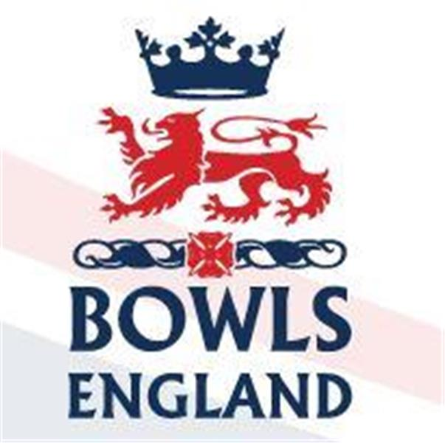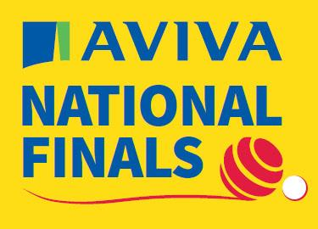
10th August to 27th August 2023 – Leamington Spa, Warwickshire.

Day 2 Review

Day 2, a day in the trenches, as players transition between the excitement of the opening day and the target of reaching finals day on Saturday

Men’s Singles

0930 saw the 2nd rd of the Men’s Singles and plenty of action across the greens. Stuart Bowman of Aspartia, Cumbria was first man into round 3 beating Tim Salter of Street, Somerset 21-11.

The streamed game was between Perry Martin of Boscombe Cliff, Hampshire, who of course beat our own Matt Larman and rising star Tom McGuinness of Gerrards Cross, Buckinghamshire. It was nip and tuck in the early stages and they were still locked together as the game moved into it’s later stages. Perry held sway at 14-13 but Tom kicked for home eventually winning 21-14.

Ashley Tanner’s conqueror Barry Hopkins from Darlington, Durham was successful again beating Martin Heitzman of Spartan and Lakeside, Sussex 21-11. 3 times champion John Ottaway from Wymondam Dell BC, Norfolk progressed 21-13 and favourite Sam Tolchard from Kings, Devon won again, 21-8. Kent’s Shaun McCaughan from Sandwich got off to a slow start and trailed 3-11, he recovered impressively though to beat Ian Mayne of Heaton Hall, Lancashire 21-19. Former Champion Andy Walters of Worcester used his experience to beat Under 18 starlet Carlos Lali from Tilehurst, Berkshire 21-11.

Onto round 3 and Tom McGuiness put down a massive marker as to his intentions as he beat Andy Walters 21-4. Barry Hopkins progressed again beating Stuart Bowman 21-10 in the streamed tie.

Shaun McCaughan got off to another sticky start and this time could not turn it round as he fell 14-21 to Darren Allsopp of New Lount, Leicestershire. John Rednall of Felixstowe and Suffolk BC, an England international with over 100 caps rolled back the years and held his undoubted nerve to topple Sam Tolchard 21-16. John Ottaway, though, was felled 19-21 by Chris McGready of the fabulously named St Georges Dragon BC, Northumberland.

Ladies Fours

The ladies also started their day at 0930 but were already onto the 3rd rd. 2022 Champion’s Lincolnshire bowed out 19-20 to Chesterton BC, Cambridgeshire.

3 members of the 2022 runners up, though, powered on with Oxford City and County winning 23-12. 2021 Winners Essex also won through to the last 8 winning 19—11. Star turn for the round though belonged to Sian Honour and her Kent four who smashed their Herefordshire opposition 27-4 in 14 ends and were done and finished before most of the other games were halfway. Gloucestershire, who ended our own Ashford quartet’s hopes could not repeat the feat and were defeated 15-27 by Warwickshire.

Onto the quarter finals. Emily Ferguson, Steph Crates, Paige Dennis and Sian Honnor had to work harder this time but they eventually overcame Betty Stewart, Dinita Plant, Jackie Wright and Janet Carter of Herts 18-12.

Sally Gilbert, Angela Service, Helen Moore and Lynn Orlando of Didcot, Berkshire beat Rachel Ashmore, Nicola Bradshaw, Becky Lever and Maureen Edwards of Rugby Thornfield, Warwickshire 20-13.

Donna Grant, Carol Gaskins, Katherine Hawes-Watts and Lorraine Kuhler from Oxford City and County overcame Heather Bell, Linda Andrews, Ann How and Jane Cullum from Chesterton 21-11 and finally the 2021 Champions Hayley Kenny, Michelle Squires, Serena Madgewick and Rebecca Smith from Clockhouse, Essex were beaten 9-16 by Jemma Touhy, Yasmina Hasan, Elizabeth Anderson and Debbie Souter of Egham BC, Surrey

Family Pairs

The last 16 saw the participation of the Ladies reduced to one as the Kent pairing including Diane Clark lost 14-19 to the Pearces of Somerset. Hayley Halford got through though joining Harry to beat the Ashby’s of Warwickshire 16-14. Leo May and his brother from Hampshire romped home 21-9 and the Reids from Bucks won 18-16 over the Sykes from Durham.

Onto the quarters and the last lady exited stage left as Harry and Hayley Halford lost 16-18 to the Sturtridges of Cornwall. Richard & George Reid though are through to the last 4 beating the Barker’s from Cambridgeshire 20-13. The strongly fancied May brothers also bowed out losing 9-16 to the Pearces. The Semi line up was completed by the Corbyn’s from Northants who beat Cumbria’s Urwin’s 16-13.

Tony Allcock Trophy

The quarter finals were played this afternoon and there were some tight ties. Henlow Park from Bedfordshire, though, conquerors of our own Bush Hill Park did not fair so well beaten 28-42 by Norfolk as one of their rinks went down 10-26.

The other games saw Cove from Hampshire win on both rinks to beat Old Coulsdon, Surrey 38-33. York Railway shared the rinks with Leicester but went down 28-34 overall. Finally Cam Mills from Gloucestershire lost 32-25 to Torquay “A”.

Men’s Two Fours

It’s a shame Bowls England don’t provide competitor names for these events on their feeds as it would be lovely to share the success of our friends from Shanklin BC, Isle of Wight who beat Reading, Berkshire 40-34. New Lount, Leicestershire beat Chipstead, Surrey 32-25 even though they shared the rinks. Worcester narrowly beat Gosforth, Northumberland 31-29 but even closer was Newmarket Avenue, Cambridgeshire v Kings, Devon. Victorious on one rink 21-11, Newmarket lost the other 8-19 to go out 29-30.

Day 3 Preview – a day of titles

Tony Allcock Trophy – 0930hrs

On Rinks B2 & B3 there is confusion in the Bowls England typing pool. Their results and their daily round up have Cove winning the Quarter final but they have, on their results pages put Old Coulsdon through. So, when they decide to agree, one of these 2 clubs will take on Norfolk!!

On rinks B3 and B4 Leicester will take on Torquay “A”

The final is scheduled for C2 and C3 at 1430hrs.

Men’s Two Fours – 0930hrs

On Rinks C1 and C2 Shanklin, Isle of Wight will take on Kings of Devon

On rinks C3 and C4 New Lount from Leicestershire will take on Worcester from, well you know that!

The final will be on C5 and C6 at a time to be determined according to the website but we reckon 1430 in line with Tony Allcock above.

Family Pairs

We are down to 4. On Rink A2 at 1230 George and Richard Reid from gerrards Cross, Bucks, will take on Michael and Neil Corbyn from Northamptonshire. Neil Corbyn is a former Junior International and part of the National Fours winners in 2012

On A6 Mark and Paul Sturtridge from Cornwall will take on Christopher and Nicholas Pearce from Somerset.

The final will be on A3 at 1530hrs.

Ladies Fours

Semi Final 1 – on A1 features Emily Ferguson, Steph Crates, Paige Dennis and Sian Honnor v Sally Gilbert, Angela Service, Helen Moore and Lynn Orlando

On paper this couldn’t be more of a mismatch – Emily Ferguson is a former Junior and Senior International, a runner up in the fours in 2018 she was also a runner up in the mixed pairs in 2013. Steph Crates and Paige Dennis are also both Junior Internationals. Sian Honnor, well, twice a commonwealth games gold medal winner, both a junior and senior international and a winner of the National triples when still in Sussex.

Semi 2 on A3 features Donna Grant, Carol Gaskins, Katherine Hawes-Watts and Lorraine Kuhler taking on Jemma Tuohy, Yasmina Hasan, Elizabeth Anderson and Debbie Souter.

Again a massive mismatch on paper. Donna Grant has won the National Singles, pairs and fours and been runner up in the triples, Katherine Hawes-Watts has won the Champion of Champions, Pairs and fours, plus runner up in the Singles and triples. She has been a Junior and Senior International. Lorraine Kuhler id about to head off to the World Championships representing England and is also both a Junior and Senior International. She has won an Atlantic Rim Gold Medal and has won the National Triples!

For the Surrey Quartet Debbie and Elizabeth are Fours Runners up and were part of the mixed fours champions in 2018

The final takes place on A6 at 1430hrs

Men’s Singles – Quarter Finals – 0930hrs

The event (and the trophy) everyone dreams of winning.

A5 – Chris McGready, St Georges Dragon BC, Northumberland v Darren Allsopp, New Lount, Leicester

A4 – John Rednall, Felixstowe and Suffolk, Suffolk v Barry Hopkins, Darlington Railway Athletic, Durham

A2 – Simon Jones, Reading, Berskhire v Tom McGuinness, Gerrards Cross, Bucks

A6 – Lewis King, Appleyard, Kent v Richard Moule, Vines Park, Worcestershire

The Semis take place at 1230 on A3 and A4 with the final at 1530 on A1 for streaming.

More tomorrow evening from a hotel somewhere near Coventry!

