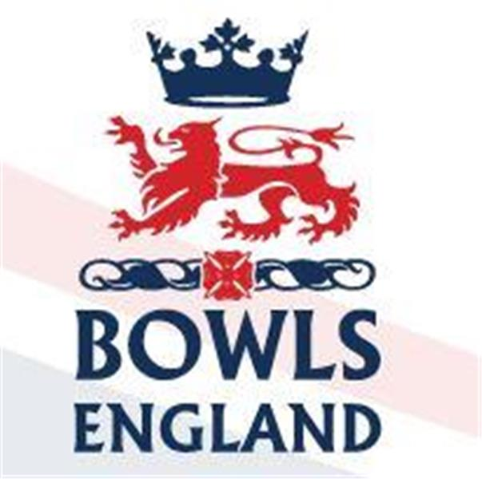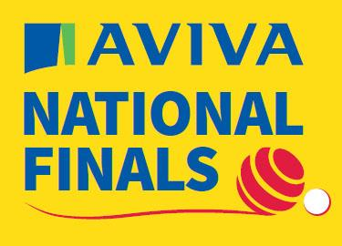
10th August to 27th August 2023 – Leamington Spa, Warwickshire.

Day 17 Review

Men’s Senior Singles

Attilio Ciampini from Uxbridge, resplendent in his new County shirt, took to D5 for his first round game against Chris Hanslip from Blossom Way, Lincolnshire. There is an end by end account of the game on the Bowls Middlesex Facebook page if you want details but to summarise Attilio struggled to get to grips with the weight of the green whilst his opponent bowled some lovely stuff. Attilio lost a 4 on the 2nd end and on the 5th Chris trailed the jack when 3 down to score 3 and lead 8-3. Attilio was only scoring in singles while his more consistent opponent was scoring doubles and trebles. At 4-11 Attilio scored a couple of singles but then lost a double. Attilio hits back and narrowed the game to 9-13 but he then lost the next 5 ends and it was 9-19. Attilio got a 2 back but the Lincolnshire man closed the game out on the next end 11-21.

In other 1st round games Stuart Evans from Shaldon, Devon beat Peter Ward from Ringwood, Hampshire. Ken Weyland from St Lawrence, Kent lost 20-21 as did Paul Broderick from Wellingborough, Northants. Ex Middlesex man Roy Spencer lost 16-21 to Somerset’s Steve Mayhew but another ex Middlesex man Michael Owen, now of East Leake, Notts, progressed 21-16.

Round 2. Stephen McAlister from Gerrards Cross won 21-17 and Chris Hanslip backed up beating Attilio by winning 21-19. Clive Burnham of Gravesend, Kent who had a walkover in the 1st rd, showed no ill effects of not having played and eased through 21-10. Howard Watts from Headington, Oxfordshire ditched the jack on the last end to beat Stuart Evans 21-19 in a dramatic finish.

Ladies Senior Singles

Bush Hill Park’s Hannah Hollis took to the green for Middlesex. Out on E1 Hannah was playing Sandra Aldridge of Ryde Marina, Isle of Wight who had earlier in the tournament been part of the title winning Senior Fours side. It was also, we found out later, Sandra’s birthday! Again, there is a detailed end by end account of this game on the Bowls Middlesex Facebook page.

Hannah got off to a slow start and trailed early 0-4. Hannah then scored her first single but Sandra got a double and it was 1-6. Hannah pulled it back to 5-6 before losing a couple of ends to trail 5-10. The game was being played at a slow pace not helped by constantly having to put water proofs on and off due to intermittent showers. Hannah again fought back to 8-10 but again Sandra dug in and moved away 8-13. Hannah scored a single but then lost 3. It was looking tough now. Sandra got another single to move with in one end of winning the tie but Hannah wasn’t going quietly. 2 singles were followed by a treble and another single 15-17.

Now the question seemed to be would Hannah have enough time to complete the comeback and get in front, let alone win the game.. The slow pace meant the Umpire had to remind them they had limited time left to play. Sandra got a single but Hannah replied with a double 17-18. 26th end and Hannah needed to win it, we think just to force an extra end, anything else is a bonus with clock against her and Umpire hovering. Hannah promptly bowls probably her best end of the game and scores 4, victory 21-17. Talk about brinkmanship.

Elsewhere in round 1 Julie Leake of Dorset and Sylvia Bloomfield of Essex both won 21-11, Gillian Barnes of Suffolk takes a nail biter 21-20 but Sue Cooke of Wiltshire coasts through 21-5.

Round 2 and Hannah faces Sue Cooke on D4. Sue was runner up in the main pairs in 2017 and this year also qualified in the mixed pairs where with her partner they downed Paul Wilshire and Karen Ryan in the last 16. In the main singles she lost 1st rd to the eventual runner up and in the 2 woods Sue lost in round 3 to Sian Honnor.

Now at this point a rookie reporting error was spotted, I had not brought my power pack and my phone was dead from reporting on 2 games already, one of them a long slow game! So for the benefit of those interested this is how Hannah’s 2nd game went:-

0-1
  - – Hannah draws shot with her last bowl
1-2
1-4
2-4
2-6
2-7
3-7
3-8 best end of the game, quality drawing but Sue still gets the shot
4-8
4-10
7-10
9-10 right back in this having played 2 much better ends
9-13 Sue knocks a short bowl in onto jack and gets 3, painful
9-14
11-14
11-15
11-18
11-21

The end, when it came, came quickly. Hannah just seemed to lose the weight slightly as the weather got chillier and the light started to fade. Sue was good enough to spot a chance and pounce. A great effort from Hannah.

Men’s Top Club

D green hosted the Semi final between Durham’s Darlington Railway Athletic and Kent’s Appleyard. Kent’s strength is in their singles play. With the 2 woods won, they also won the Singles. That meant they only needed to win one of the team events and at the conclusion of the singles they were streets ahead in the pairs so the game was ended. Darlington were at that stage ahead in triples and fours so the result was declared 3-2.

On B green Devon’s Shaldon played the Isle of Wight’s Shanklin. Shanklin took the 2 woods but everything else was going down to the wire. Shaldon took the singles but Shanklin won the pairs on the last end. Shaldon took the fours on the last end so it was down to the triples. With a couple in it with 2 to play it looked to be going down to a last end shoot out but the Shanklin skip played a magic take out with his last bowl of the 17th end to send Shanklin down the last end 6 in front. Shaldon couldn’t get the big count they needed and Shanklin were into another final having already won the club double fours.

Onto the final on A green. Appleyard won the 2 woods but got turned over in the Singles as Jack Berry thumped Harry Goodwin. Shanklin won the pairs again but narrowly lost the fours. So again all down to the triples but this time there was less drama as Appleyard had already pulled ahead. They held Shanklin at bay to take the title 3-2. Congratulations to them.

Ladies Top Club

The semi’s saw Kings, Devon take on Royston from Hertfordshire. Royston narrowly took the pairs but were well beaten in the other 3 disciplines as King’s progressed to yet another final.

On A green Appleyard were taking on Egham and this went down to narrowest of wires. Yasmina Hasan won a quality singles game by 3 to put Egham ahead but the Kent side took the triples by 4! Egham took the pairs by 6 but were behind in the fours which was being streamed. 7 down starting the last end Egham needed 2 to force an extra end on all the 3 team disciplines. With the skips to play they held 1, possibly 2 and a measure for third. Sian Honnor, gold medal winning International, was the Kent skip but she could not alter the position with her 3 woods. Kelly Jenkins had the last bowl and she was high, wide and well short. Deliberate or not, was she more confident of the position than us watching in the stands. The measure came out 1, 2 and close but 3. Egham had lost the fours but won the tie by 1 shot 65 – 66. Gripping stuff.

Onto the final on B green, which is significantly slower than A. Yasmina again won the singles, by 10 this time. Egham also took the triples by 8. Kings hit back to win the pairs but only by 4. So over to the fours, well sadly this was a one sided affair with ……..Appleyard winning 29-8. So 2-2 on disciplines but the margin on the fours meant 63-53 to Kings on shots. Kings were champions for an incredible 5th year on the trot. Can they make it 6, not going to be putting any money down against it that’s for sure!!

Day 18 Preview

Men’s Senior Singles

Quarter finals at 0930. On A Green Stephen McAlister of Gerrards Cross, Bucks will take on Graham Ashby of Nuneaton, Warwickshire who has already won the Champion of Champions title at this tournament. Steve Poyner of Vines Park, Worcestershire will play Clive Burnham of Gravesend, Kent.

On D green Chris Hanslip of Blossom Way, Lincolnshire will face Robin Waterhouse from Newmarket Avenue, Cambridgeshire and Michael Owen from East Leake, Nottinghamshire will face Howard Watts from Headington, Oxfordshire.

Ladies Senior Singles

All on D green at 0930hrs. Sylvia Bloomfield of Harlow, Essex faces Sue Allen of Swinton, Yorkshire. It’a a battle of the Gillian’s on D6 as Hill from Eastbourne, Sussex faces Barnes from Boxford, Suffolk. Margaret Smith from Sutton, Surrey faces Hannah’s conqueror Sue Cooke from Box Wiltshire and finally Debbie Roe of Stotfold, Bedfordshire faces Kate Kyle of Shepshed Town, Leciestershire.

Walker Trophy

The Semi Finals of the Ladies County Double rink will see Berkshire face Lincolnshire and Norfolk face Cornwall, both ties on A green at 0930hrs

Middleton Cup

Defending champions Berkshire will face locals Warwickshire in the Semi on B Green whilst Lincolnshire will face Huntingdonshire on C green.

Lincolnshire last won the title in 1996, Huntingdonshire have twice been runners up in 2007 and 2010, Warwickshire last won the title in 1970 when they beat Middlesex!

More when I catch up!

